**Practical No 07**

**X.1**

* **Program:**

<?xml version="1.0" encoding="utf-8"?>

<androidx.constraintlayout.widget.ConstraintLayout xmlns:android="http://schemas.android.com/apk/res/android"

xmlns:app="http://schemas.android.com/apk/res-auto"

xmlns:tools="http://schemas.android.com/tools"

android:layout_width="match_parent"

android:layout_height="match_parent"

tools:context=".MainActivity">

<AbsoluteLayout

android:layout_width="match_parent"

android:layout_height="match_parent"

android:orientation="vertical">

<TableLayout

android:layout_width="350dp"

android:layout_height="300dp"

android:layout_x="20dp"

android:layout_y="100dp">

<TableRow

android:layout_width="match_parent"

android:layout_height="match_parent"

android:gravity="center">

<TextView

android:id="@+id/TextView"

android:layout_width="wrap_content"

android:layout_height="wrap_content"

android:gravity="center"

android:text="Login Page"

android:textSize="35sp"/>

</TableRow>

<TableRow

android:layout_width="match_parent"

android:layout_height="match_parent">

<TextView

android:id="@+id/textView1"

android:layout_width="wrap_content"

android:layout_height="wrap_content"

android:text="Username"

android:textSize="25sp"/>

<EditText

android:id="@+id/user"

android:layout_width="wrap_content"

android:layout_height="wrap_content"

android:ems="10"

android:inputType="textPersonName"/>

</TableRow>

<TableRow

android:layout_width="match_parent"

android:layout_height="match_parent">

<TextView

android:id="@+id/textView3"

android:layout_width="wrap_content"

android:layout_height="wrap_content"

android:text="Password"

android:textSize="25sp"/>

<EditText

android:id="@+id/pass"

android:layout_width="wrap_content"

android:layout_height="wrap_content"

android:ems="10"

android:inputType="textPassword"

android:textSize="20sp"/>

</TableRow>

<TableRow

android:layout_width="match_parent"

android:layout_height="match_parent"

android:gravity="center">

<Button

android:id="@+id/btn"

android:layout_width="wrap_content"

android:layout_height="wrap_content"

android:gravity="center"

android:text="Submit"/>

</TableRow>

</TableLayout>

</AbsoluteLayout>

</androidx.constraintlayout.widget.ConstraintLayout>

* **Output:**

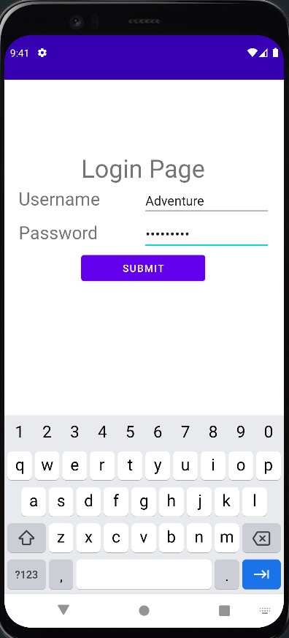

# **X.2**

* **Program:**

<?xml version="1.0" encoding="utf-8"?>

<androidx.constraintlayout.widget.ConstraintLayout xmlns:android="http://schemas.android.com/apk/res/android"

xmlns:app="http://schemas.android.com/apk/res-auto"

xmlns:tools="http://schemas.android.com/tools"

android:layout_width="match_parent"

android:layout_height="match_parent"

tools:context=".MainActivity">

<AbsoluteLayout

android:layout_width="match_parent"

android:layout_height="match_parent"

android:orientation="vertical"

tools:layout_editor_absoluteX="16dp"

tools:layout_editor_absoluteY="78dp">

<TextView

android:id="@+id/tetView"

android:layout_width="206dp"

android:layout_height="wrap_content"

android:layout_x="100dp"

android:layout_y="78dp"

android:gravity="center"

android:text="Student Details"

android:textSize="30sp"

android:textAlignment="center"/>

<Button

android:id="@+id/btn"

android:layout_width="125dp"

android:layout_height="50dp"

android:layout_x="140dp"

android:layout_y="511dp"

android:text="Button" />

<TableLayout

android:layout_width="350dp"

android:layout_height="340dp"

android:layout_x="29dp"

android:layout_y="165dp">

<TableRow

android:layout_width="280dp"

android:layout_height="wrap_content"

android:gravity="center" />

<TableRow

android:layout_width="314dp"

android:layout_height="match_parent">

<TextView

android:id="@+id/Name"

android:layout_width="127dp"

android:layout_height="wrap_content"

android:text="Name"

android:textSize="16sp" />

<EditText

android:id="@+id/editTextTextPersonName"

android:layout_width="wrap_content"

android:layout_height="wrap_content"

android:ems="10"

android:inputType="textPersonName"

android:textSize="16sp" />

</TableRow>

<TableRow

android:layout_width="match_parent"

android:layout_height="match_parent">

<TextView

android:id="@+id/Name1"

android:layout_width="123dp"

android:layout_height="wrap_content"

android:text="Address"

android:textSize="16sp" />

<EditText

android:id="@+id/editTextTextPersonName1"

android:layout_width="wrap_content"

android:layout_height="wrap_content"

android:ems="10"

android:inputType="textPersonName"

android:textSize="16sp" />

</TableRow>

<TableRow

android:layout_width="match_parent"

android:layout_height="match_parent">

<TextView

android:id="@+id/Name2"

android:layout_width="123dp"

android:layout_height="wrap_content"

android:text="Class"

android:textSize="16sp" />

<EditText

android:id="@+id/editTextTextPersonName2"

android:layout_width="wrap_content"

android:layout_height="wrap_content"

android:ems="10"

android:inputType="textPersonName"

android:textSize="16sp" />

</TableRow>

<TableRow

android:layout_width="match_parent"

android:layout_height="match_parent">

<TextView

android:id="@+id/Name3"

android:layout_width="123dp"

android:layout_height="wrap_content"

android:text="College"

android:textSize="16sp" />

<EditText

android:id="@+id/editTextTextPersonName3"

android:layout_width="wrap_content"

android:layout_height="wrap_content"

android:ems="10"

android:inputType="textPersonName"

android:textSize="16sp" />

</TableRow>

<TableRow

android:layout_width="match_parent"

android:layout_height="match_parent">

<TextView

android:id="@+id/Name4"

android:layout_width="123dp"

android:layout_height="wrap_content"

android:text="Mobile No"

android:textSize="16sp" />

<EditText

android:id="@+id/editTextTextPersonName4"

android:layout_width="wrap_content"

android:layout_height="wrap_content"

android:ems="10"

android:inputType="textPersonName"

android:textSize="16sp" />

</TableRow>

<TableRow

android:layout_width="match_parent"

android:layout_height="match_parent">

<TextView

android:id="@+id/Name6"

android:layout_width="123dp"

android:layout_height="wrap_content"

android:text="Branch"

android:textSize="16sp" />

<EditText

android:id="@+id/editTextTextPersonName6"

android:layout_width="wrap_content"

android:layout_height="wrap_content"

android:ems="10"

android:inputType="textPersonName"

android:textSize="16sp" />

</TableRow>

<TableRow

android:layout_width="match_parent"

android:layout_height="match_parent">

<TextView

android:id="@+id/Name7"

android:layout_width="123dp"

android:layout_height="wrap_content"

android:text="Email"

android:textSize="16sp" />

<EditText

android:id="@+id/editTextTextPersonName7"

android:layout_width="wrap_content"

android:layout_height="wrap_content"

android:ems="10"

android:inputType="textPersonName"

android:textSize="16sp" />

</TableRow>

<TableRow

android:layout_width="match_parent"

android:layout_height="match_parent" />

</TableLayout>

</AbsoluteLayout>

</androidx.constraintlayout.widget.ConstraintLayout>

* Output:

